**V16 Metal Mouthpieces “The new Chambers of Jazz”**

Introduction

The first metal mouthpiece I ever purchased was a Vandoren V16 T45 with a Vandoren Optimum ligature. When I was at the 2014 NAMM show and spoke with Vandoren Brand Manager, Andy Blanco, he told me that Vandoren has re-released the popular V16 metal mouthpiece and introduced a medium and large chamber. Andy was nice enough to send me a Vandoren V16 Trail Kit with three T7 small, medium, and large chamber mouthpieces in addition to a T8 small and medium chamber mouthpiece. The trail case also came with a Vandoren Optimum ligature with 3 different plates to choose from and I decided to stick with the plate with the waves or Plate N 1. I will be reviewing this mouthpiece based on the Tone, Intonation, Build Quality, and my Overall thoughts.

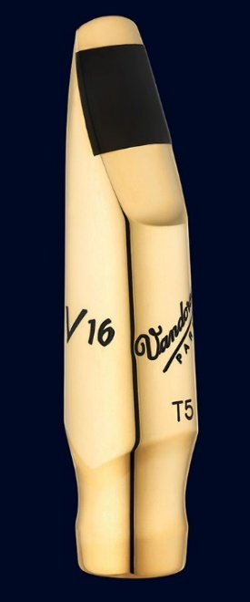

**Tone**

**T7 Small**

The T7 small chamber reminded me the most of my T45 mouthpiece except the T7 was a larger tip opening. I found the T7 small chamber to project well and produce a smooth bright tone with little edge. I found this mouthpiece was very free blowing similar to my T45 and the Vandoren Optimum ligature complimented this mouthpiece very well.

**T7 Medium**

The T7 medium chamber is one of Vandoren’s newest additions to the metal Vandoren V16 line of mouthpieces. According to the Vandoren, “the medium chamber was inspired by the famous mouthpieces from the 50’s and 60’s containing a round and deep sound.” I enjoyed playing the medium chamber mouthpiece because I felt there was a little bit more resistance (not in a bad way) which gave me something to push against and achieve more tonal colors and edge which is something that I am looking for. This medium chamber reminded me more of some of the early Babbitt and double ring link’s I have tried in terms of the edge and projection found in many of these mouthpieces. Overall, the T7 medium chamber has an edge, focus, and resonance that embodied some of the great characteristics found in of some of the great Otto links, Dukoff Stubby, and many other great mouthpieces form the 50’s and 60’s.

**T7 Large**

In addition to the medium chamber, Vandoren has introduced a large chamber mouthpiece that is supposed to be reminiscent of the mouthpieces form the 40’s embodying the “great vintage sound.” I found the larger chamber to have a dark and mellow sound but also this mouthpiece could take a lot of air producing a very big robust sound that did have a focus to it and was not as spread as I thought it would be.

**T8 Small**

Although the T8 small might have been too big of a tip opening for me, the bright, focused sound was still there.

**T8 Medium**

Like the T8 small, the T8 medium was a bit too big of a tip opening for my preference but I found the same characteristics in this mouthpiece as I did the T7 and the T8 was still very playable even though it was a larger opening than I am used to.

**Intonation**

For a metal mouthpiece, the Vandoren V16 has great intonation and while working thru my overtone exercises, I found that when I was moving thru the palm keys and altissimo that the sound was very stable and easy to control without the sound becoming shrill or thin.

**Build Quality**

The Vandoren V16 metal mouthpiece is “made with the legendary “Bell Metal” brass, then plated with 24-karat gold. The rails and tips between all five mouthpieces were consistent and I did not see any signs of blemishes nor inconsistencies in any of the mouthpieces. Cosmetically the mouthpiece reminds me of a double ring Otto link as well as a dukoff stubby in terms of how the mouthpiece looks at the end of the body and into the shank.

**Overall**

Whether you enjoy the characteristics of the small, medium, or large chamber, I think Vandoren has re-released and expanded upon a great metal mouthpiece that embodies focus, edge, resonance, darkness, brightness, projection, etc. If you already own the original V16 metal, then I would recommend checking out the medium and large chamber to find out which one you would prefer. On the other hand, if you are looking for a vintage Otto Link, Dukoff, Berg, etc, I would add the Vandoren V16 Medium and Large Chamber to your list because I think you will be surprised what you can get out of a new metal mouthpiece. I personally enjoyed playing on the T7 medium chamber mouthpiece but would like to try a T6 medium chamber just to figure which opening would be the right fit. Again, I would like to thank Andy Blanco for allowing me the chance to try these great additions to the Vandoren product line.

Please leave any questions or comments.

Links

Vandoren

<http://www.vandoren-en.com/Tenor-metal-V16-Saxophone-mouthpieces-T5-T6-T7-T8-and-T9_a682.html>

Lucas Pino Playing the V16 Metal Mouthpiece

<http://www.youtube.com/watch?v=dPGzyZ3IFIE&list=UUEMwVy7W1o7U9egRlPztdAw>